1. Local reference can be applied on tag in your template.
2. **Syntax**: <tagName **#referenceName**>🡸 This would contain only reference to an element. 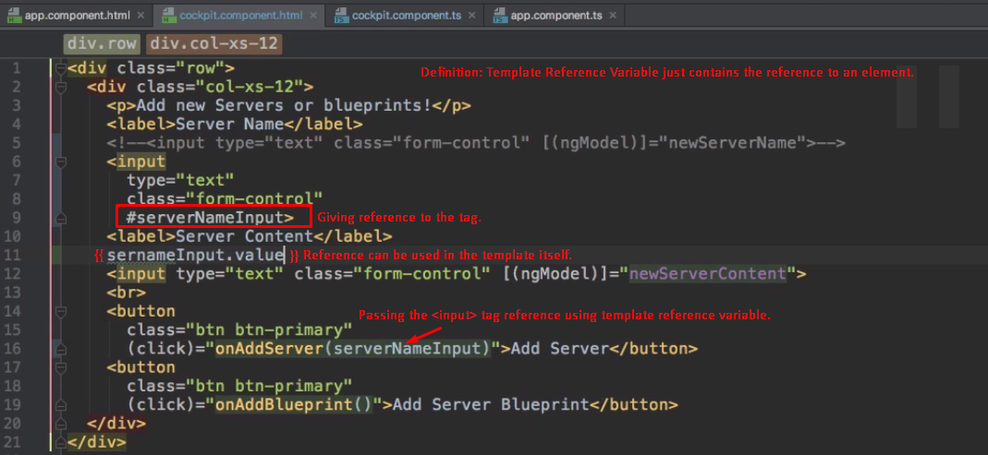
3. 